**UNIVERSITY OF CAPE COAST**

**COLLEGE OF HUMANITIES AND LEGAL STUDIES**

**SCHOOL OF BUSINESS**

**CENTRE FOR ENTREPRENEURSHIP AND SMALL SCALE ENTERPRISE DEVELOPMENT**



**COURSE**: SBU 408 INTRODUCTION TO ENTREPRENEURSHIP

**LECTURER**: DR. EDWARD NII ARMAH ARMATEFIO

**ASSIGNMENT**: BUSINESS PLAN FOR A TEA SHOP

**TEAM MEMBERS’ DETAILS**

**NAMES INDEX NUMBERS**

Seth Annan SB/ADM/15/0005

Helena Mensah SB/ADM/15/0042

Evelyn Kukuwa Quartey SB/ADM/15/0063

Michaela Otoo SB/ADM/15/0071

James Eyiah Mainza SB/ADM/15/0078

Jennifer Cudjoe SB/ADM/15/0093

Sekyiwa Edu Rose SB/ADM/15/0135

Richard Ofori Danso SB/HRM/15/0008

Theophilus Armah SB/MKN/15/0034

George Mawuli Gamlie SB/PCM/15/0006

# BUSINESS PRINCIPALS

NAME OF BUSINESS: Tea Crush Enterprise

ADDRESS: P.O.BOX 256, Cape Coast

LOCATION: Oye Inn Hostel, opposite science station, UCC

WEBSITE: [www.teacrush.com](http://www.teacrush.com)

EMAIL: teacrush164@gmail.com

CEO: Mr. James Eyiah Mainza

CONTACT: +233-248-062-191

EMAIL: jamesopmainza@gmail.com

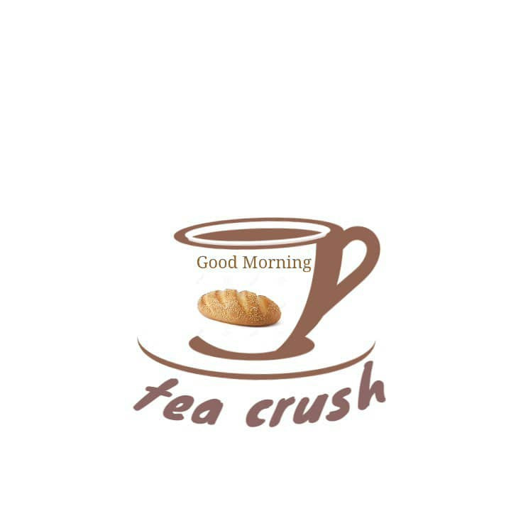

**Business Logo**

**Confidentiality Statement**

The information in this document is confidential to the TEA CRUSH, to whom it is addressed and should not be disclosed to any other person. It may not be reproduced in whole, or in part, nor may any of the information contained therein be disclosed without the prior consent of the directors and Forerunners of the business. A recipient may not solicit, directly or indirectly (whether through an agent or otherwise) the participation of another institution or person without the prior approval of the directors of the business.

The contents of this document have not been independently verified and they do not purport to be comprehensive, or to contain all the information that a prospective investor may need. No representation, warranty or undertaking, expressed or implied is or will be made or given and no responsibility or liability is or will be accepted by the Business or by any of its directors, employees or advisors in relation to the accuracy or completeness of this document or any other written or oral information made available in connection with our business

Any form of reproduction, dissemination, copying, disclosure, modification, distribution and or publication of this material is strictly prohibited.

**Disclaimer**

Although the information contained herein is believed to be reliable, TEA CRUSH or its Advisors or Consultants make no representation as to the accuracy or completeness of any information contained herein or otherwise provided by TEA CRUSH. The terms set forth herein are intended for discussion purposes only and subject to the final expression as set forth in a definitive agreement and / or confirmation.

To the best of the knowledge of the Directors of TEA CRUSH, the information contained in this business proposal is correct. The aims, strategies, target, plans, intentions and projections referred to in this business plan are based upon assumptions which the directors consider reasonable, but any projections do not constitute forecasts and are subject to variation.

**TABLE OF CONTENTS**Confidentiality Statement ............................................................................................................4  
Disclaimer.....................................................................................................................................4  
TABLE OF CONTENTS..............................................................................................................5  
1.0 EXECUTIVE SUMMARY ....................................................................................................7  
2.0 COMPANY OVERVIEW ......................................................................................................9  
2.1 INTRODUCTION.............................................................................................................................9  
2.2 Vision And Mission..............................................................................................................................9  
2.3 History And Current Status..................................................................................................................11  
2.4 Objectives.............................................................................................................................................11  
3.0 PRODUCT AND SERVICES ................................................................................................11  
3.1 Service Features....................................................................................................................................11  
3.2 Customer Benefits................................................................................................................................13  
3.3 Proprietary Rights ...............................................................................................................................13  
3.4 Stage Of Development.........................................................................................................................13  
4.0 MARKET AND INDUSTRY ANALYSIS ..........................................................................14  
4.1 Demographic information:..............................................................................................................14  
5.0 MARKETING PLAN ...........................................................................................................15  
5.1 Target Market Strategy........................................................................................................................15  
5.2 Place.....................................................................................................................................................16  
5.3 Product Strategy ..................................................................................................................................16  
5.4 Promotional/CommunicationStrategy............................................................................................17  
5.5 Sales Strategy.....................................................................................................................................18  
5.6 Revenue Model .................................................................................................................................19  
6.0 OPERATIONAL PLAN ........................................................................................................19  
6.1 Geographical location ..........................................................................................................................19  
6.2 Facilities and Improvements.................................................................................................................196.3 Strategy and Plans.................................................................................................................................20  
6.4 Regulatory and Legal issues ................................................................................................................20  
6.5 Operational Strategies ..........................................................................................................................20  
6.6 Developmental Strategies.....................................................................................................................21  
7.0 MANAGEMENT TEAM ......................................................................................................22  
7.1 Management And Legal Backing....................................................................................................22  
7.2 Members And Offices.......................................................................................................................22  
8.0 CRITICAL RISK, PROBLEMS AND ASSUMPTIONS .....................................................23  
8.1 Uncertainty About The Future .......................................................................................................24  
8.2 Financial Management ...................................................................................................................24  
8.3 Regulation And Compliance ..........................................................................................................24  
8.4 Competencies And Recruiting The Right Talent ...........................................................................24  
8.5 Technology......................................................................................................................................25  
8.6 Customer Service ...........................................................................................................................25  
8.7 Maintaining Reputation ..................................................................................................................25  
8.8 Knowing When To Embrace Change..............................................................................................25  
9.0 FINANCIAL PLAN...........................................................................................................26  
9.1 Per Head Contribution ....................................................................................................................26  
9.2 Makeups consult forecasted income................................................................................................27  
10.0 APPENDICES .................................................................................................................29

REFERENCES ........................................................................................................................31

**EXECUTIVE SUMMARY**

TEA CRUSH will be the only Tea Shop to be located in the University of Cape Coast (UCC) campus in the Central Region of Ghana. Due the hustle UCC students encounter by waking up for morning lectures and quizzes, they find it difficult to prepare breakfast which keep them going for the day’s activity. Starting a day’s activity with breakfast help boost your metabolism and keep your sugar level stable during the day as well as the brain. A nutritious breakfast helps build one’s concentration level and productivity. Tea contains antioxidants, has less caffeine than coffee, may reduce the risk of heart attack and stroke and may help in weight loss and may also help protect your bones and keep your smile bright. Tea Crush will be a newly established firm and perhaps the first of its kind in UCC that will continue in operational existence for the foreseeable future. Aside running our services to provide the best breakfast in a very modernized way, we will be committed to give professional training to young interns who would want to engage in same or similar business in future at very affordable fees. Plans are underway to open branches at University of Education and Kwame Nkrumah University of Science and Technology since our feasibility studies proved that there are no Tea Shops in the above universities. We will be so objective to perusing quality in our services at our unit, at gatherings and when on call. We will therefore, be cost friendly, durable in our services, in order to meet the need of our loyal customers.

We are in business to not only make profit but also to compete favorably with similar business (startups or established) here in University campus and also all over the Cape Coast town and possibly as a nationwide outstanding Tea Shop. Our vision is not only to meet the expectations of our customers and exceed it but also to become a national and international brand by the year 2028.

We intend to not only concentrate on our core offering; this means that we would be offering other services that are intended to boost our income and make us have a healthy bottom line in which to sustain our business. Our promotional strategies are top notch as we already have a popular channel on WhatsApp platform and still working on a YouTube site where we will always give tips and advice to our audience. We could also give out trainings to our international clients through the YouTube.

Our customers are very important to us and so we intend to leave them fully satisfied with our services. We would be offering discounts and incentives especially during festive seasons intended to keep our loyal customers with us while also luring away clients from our competitors to us.

We have built a solid business structure because we intend to start with as few hitches as possible. We have sourced for competent and qualified staffs who understand the business thoroughly and will do all they could to ensure that we get to the top. Our staff is the best in the field.

In terms of the industry organization, this is how the industry will organized; the chief executive officer will be James Eyiah Mainza and he will see to the overall running of the business. The chief consultants include Seth Annan and Evelyn Kukuwa Quartey. Also, our noble consultants will include Sekyiwa Edu Rose, George Mawuli Gamlie and Michaela Otoo. Helena Mensah and Theophilus Armah will be the public relations officers. The financial team will consist two vibrant young persons, named Richard Ofori Danso and Jennifer Cudjoe. But in a situation where we have more customers in high numbers the other staffs will also part take in serving our customers and we shall also seek to employ other persons with high qualification like us to increase our staff capacity, to aid in quick delivery of our services.

Our source of finance will come from the contributions of the team members. Our projected startup capital is GHS 13,700.00 and it is intended to be generated from within the team. Considering the large market size, suitability of site and other favorable conditions, the business is expected to begin generating profit in about six (6) months after its commencement.

**COMPANY OVERVIEW**

**Introduction**

The name of our business is Tea Crush. It is going to be a unique and standardized business run within Cape Coast and outside Cape Coast. Tea Crush will be a newly established firm that will run the only modern tea shop specifically in UCC (primary location) as well as the entire Cape Coast. Tea Crush will be a partnership business to be registered under the Incorporated Private Partnerships Act 1962 (Act 152). Aside running our services to provide the best tea in a unique way to our customers at quality but affordable prices, we will be committed to give professional training to young interns, who would want to run similar business in future at moderate fees. Our indomitable business will be cost friendly, in order to meet the need of our customers.

Plans are underway to open new branches at University of Education and Kwame Nkrumah University of Science and Technology in future since our feasibility studies proved that there are no Tea Shops in the above universities.

**Vision Statement**

To be established and trusted as the perfect tea business and to be the leader in the market.

### **Mission Statement**

To provide perfect, delicious tea products and excellent and reliable services to our customers.

### **Core Values**

* Proactive
* Integrity
* Reliable
* Honesty
* Excellency
* Teamwork

#### **History and Current Status**

As business minded group on campus, we undertook a feasibility studies on the students and we realized that due to the hustle UCC students encounter by waking up for morning lectures and quizzes, they find it difficult to prepare breakfast which keep them going for the day’s activity. From our research, we realized also that some students had lectures from morning till evening on certain days whilst others spend almost the whole day at the Sam Jonah Library learning and researching. From our personal observations, there’s no Tea Shop in the university community as students who preferred light foods in the morning often resort to Bisap, Ice Kenkey, just to mention few. Others are left with no option than buying Capo Chino which also cost not less than GHS 8.

Some goes to Sasakawa Restaurant, Club House, School of Business Restaurant, Institute of Education restaurants for very expensive breakfast at higher rates.

From our personal observations, those who sell ice kenkey, bissap sometimes get their bottles from empty bottles from funerals, outdooring, and other wedding activities. This idea of poor quality services on the part of our competitors and the ostentatious price charged by some restaurant on campus, cajoled us to establish a business to serve the needs of all our customers on campus and outside campus. We shall also be mobile in order to serve other nearby towns.

We currently exist as a small company on campus, adjacent the Taxi Rank at Science.

Plans are underway to acquire vending machines so as to run services for customers at their various halls of residents when we are call upon. We currently comprise a team of vibrant members who spend sleeplessness nights to making sure that the company meets its target.

**Objectives**

To help meet students’ breakfast needs.

**PRODUCT AND SERVICES**

**Product Features**

Our tea comes with different kinds to suit students’ preference such as tea with more sugar and more milk, tea with no sugar but more milk, and other beverages like Milo, Cowbell strawberry, Mocher and Cowbell Coffee.

The tea would be available with sandwich that is, round bread with egg, round bread with salad (cabbage, canned beef sardine and egg) based on the preferences of customers.

The nutrients that tea contain include Tannins, caffeine and tea vitamins such as vitamin E, vitamin B, vitamin C, Theanne, plants pigment, alkalinity, fluorine and saponins.

The unique characteristics of our product are; it is in a plastic disposable cup sealed with a straw. There are no additives, it is creamy. Tea drinks are highly nutritious and rich in Riboflavin (vitamin B2) that is 11% of the Reference Daily Intake (RDI), Pantothenic Acid (Vitamins B5): 6% the RDI, and Vitamin B3: 2 % of RDI. Tea also contains L-theanine, theophylline and bound caffeine (sometimes called theine).

Several observations studies show that, tea drinkers have much lower risk of type 2 diabetes, a serious condition that affects millions of people worldwide. Again, tea drinkers according to the observations of the researchers have up to 60% lower risk of getting Parkinson disease, the second most common neurodegenerative disorder. The most exciting news about tea drinkers is that, they have a much lower risk of cirrhosis, which can be caused by several diseases that affects the liver. Tea varies from noted brands to organic herbal such as black tea or green tea. Our tea will be in different varieties; green tea, strawberry tea, lipton, milo.

We give our customers value for their money by providing them with a product is of very high quality and yet at a very affordable price of GHS 1.00

**Customer Benefits**

Our cherished customers are really going to find our services useful. We are going to give them value for their money. Customers are going to get the following benefits:

* We are going to give them convenience services. Customers do not have to always walk to our shop to buy if it will not favor them. Looking at our target customers who are mostly students and lecturers, they are almost always busy and cannot go through the hustle of coming to our shop to buy a cup of tea. Our mobile services will give such customers a relief. This will ensure convenience.
* Our services will be time saving. Once again our mobile services will save a lot of time and customers most especially lecturers do not have to make time out of their busy schedules to come out of their offices to buy tea.
* Our services will be of the best quality with good hygienic environment
* Lastly we are going to provide affordable services. Our prices are as low as GHS1

### **Proprietary Rights**

Tea Crush is a private property of group 10 members (Seth Annan, James Eyiah Mainza, Evelyn Kukuwa Quartey, Sekyiwa Edu Rose, Jennifer Cudjoe, Richard Ofori Danso, Helena Mensah, Michaela Otoo, Theophilus Armah and George Mawuli Gamlie) and this group shall have the rights to;

* determine the use of property
* income or proceeds from property
* delegate, sell, or rent any portion of the rights to the property

### **Stage of Development**

Our services are in the early stages of design and is in development but all enquires, strategies and personnel to facilitate the business is ready. Development will be ready in two months. The major obstacle to the development is finances to procure raw materials, vending machines and availability of land for establishment of the shop.

**MARKET AND INDUSTRY ANALYSIS**

**Market Assessment.**

The market consists of heterogeneous customers but our target market is the university community especially students on campus. The University has a current population of over 28,000 students in addition to the 6,000 residents summing up to 34,000 and the breakdown is as follows;

**MALES: 23,000**

**FEMALES: 11,000**

Focus will be on the undergraduate regular students during the normal session of the school as well as the residents within the university community. Our target market shall be students and lecturers of the entire UCC campus and the inhabitants of the Amamoma community and we expect to capture 50% of this number within the first two years of our operation, giving our quality product provision and continuous review of our product. The current statistics available indicate that the urban population in Ghana is 51% of the total population the country and also with a 3.4% annual rate of change between 2010 and 2015.

The above statistics indicate a promising future for the demand and consumption of tea. Customers are now relying on fruits juices without additives to satisfy their need.

This is because those engaged in this business are not able to provide up to customer’s special needs. The prices of our products will be quoted in litres depending on the size of the disposable cups. To distinguish ourselves with respect to prices, our prices would be 5% less of the prevailing market price.

**The Competitive Environment**

The competitors of our product are wholesalers, retailers, restaurants and other dealers of popular brands of tea, porridge, and Nescafe sellers in the university community. In particular, cafeterias and snack bars on campus are our direct competitors. However, in view of this stern competition from all facets, our competitive advantage remains the natural taste of our product and its uniqueness.

We would use cost effective methods of production so as to make our product more affordable, without compromising on its quality. Also due to the ease of entry, as a result of low capital requirement, we plan to use the differentiation approach to sustain our competitive advantage due to the unique and peculiar nature of our product.

## **MARKETING PLAN**

### **Target Market Strategy**

The market consists of heterogeneous customers but our target market is the university community especially students on campus. The estimated number of our main target market (students) is about 19,000 (source: Data Processing Unit of UCC) and we expect to capture 50% of this number within the first two years of our operation, giving our quality product provision and continuous review of our product. As a business, the value of our customers and their satisfaction is paramount.

The price of our product will be designed to reflect the quality, degree of expertise, specialization and value creation. The prices would also be designed to revolve around “the four Cs of pricing” which include,

Customer: Charging a well-conceived price that will be attractive to our clients

Company: Charging a comparable price that would help the firm to make the planned profits as well as ensuring the survival of the firm.

Competition: Charging a comparable price that would help beat competition.

Constraints: Charging price that would help minimize threats arising from price competition.

**Place**

The business will be located at Oye Inn, Amamoma near the Prudential Bank. The choice of this location is due to the fact the area is very close to campus and major roads connecting to the various and hostels and halls lies in this area. The shop will be directly opposite the Science Station. A well designed logo will be placed in front of the shop and glass doors shall be used so as to expose the contents of shop coupled with the internal beauty.

### **Product Strategy**

Products that will be sold at the shops includes all sort of Tea and its accompaniment. Plans are underway to include other beverages to meet all the changing needs of our large market size.

Tea will be sourced from plant called Camellia Sinensis. The tea is transported to our production site for production to begin.

The Camellia Sinensis beans, after passing through quality testing are broken to pieces by the use of a grinder or blender. The finer the granules, the stronger the tea. Coarser grounds produce better flavor and less bitterness if you are making drip coffee.

The grinded Camellia Sinensis is poured into hot water. A little sugar is added to reduce the bitterness hence making it a little sugary for our taste conscious consumers while natural flavours without sugar is separated for customers who prefer no sugar to their diet. Preservatives are added and source is neatly bottled into well labelled bottles by the bottling department, ranging from 0.5 litres, 1 litre, 1.5 litres, 3 litres and 5 litres containers respectively. The 0.5 litres will be packaged into groups of 30 bottles, 1litres in groups of 15 bottles, 1.5 and 3 litres will be packaged in groups of 10.

The 5 litre bottles will be packaged individually and all products subjected to scrutiny by our quality control team before finished products are transferred to our warehouse. Raw materials which include not only the grinded tea granules, but also milk, milo, lipton, disposable cups and bottles, bread, corned beef, sardines among others.

**Promotional/Communication Strategy**

As a new establishment on campus, awareness has to be created in order to increase patronage. We will therefore make a nice eye catching logo, banners, displaying our products on billboards, radio stations, social media platforms like facebook, whatsapp, instagram, twitter, and YouTube.

Our products will be well displayed on these platforms by employing the service of most popular students on campus to be used in our ads and commercials. To make customers feel welcome and appreciated, each customer shall be given one of our well designed stickers with our logos on it.

There is a higher probability that every customer may use this sticker on her laptop, door, and electrical appliance like fridge and furniture like wardrobe. In so doing, our products will be advertised by our customers and increase patronage from other clients. Also, promotions shall be run. Promotions make customers feel like they are part of a team/ movement where there is a higher probability of winning. This will cause people to buy more in order to increase their chances of winning. More buying more money. Discounts will be given on exceeding purchase on a number of some products. The aim of these strategies is to increase awareness of the products and brand to gain advantage over our competitors, gain immediate response to drive sales and maintain the interest of customers in the products.

**Sales Strategy**

Popular products have the greatest selling potential. As these products are well advertised on social media, radio and television sets, the next step is to increase ease of accessibility. Though the business is situated in a good environment, certain sections of the school are quite far from the center hence door to door to deliveries will be made available to these centers. Also we will be organizing seminars and documenting our works in the various campus magazines will help increase sales. Management has planned to buy vending machines in almost all the halls of residence in the university campus by year 2020. Due to increase in online shopping and scam attacks on web users, the establishment will have its own website where one can but any product at affordable price without having to worry about security issues on his transactions.

**Revenue Model**

Selling the products in its environs, paying commission to customers who bring different people into the establishment, online and door to door transport of our services will be given a lot of priority.

## **OPERATIONAL PLAN**

## **Geographical location**

Tea Crush will have its main service station located on the forecourt of Oye Inn Hostel opposite Science Station in the University of Cape Coast. The location was strategically chosen near one of the busiest streets in the University campus since our target market will be students, lecturers, and inhabitants of the nearby towns. It is a high profile area, with easy access from all parts of the campus and its surrounding suburbs.

### **Facilities and Improvements**

Our service center will comprise of three (3) rooms, one serving as the main administration, others production room and Serving room respectively. In order to add to our client’s experience, the serving room will be well furnished with modern equipment: good lighting and proper ventilation. Also, GE Reveal bulbs, which mimic bright sunshine will be used at night in order to extend our working hours to improve client’s attendance. In addition, sophisticated tools such as catering tools, bulk disposable tools, ultra-modern chairs such as foldable chairs for mobile services, four-star dining table with proper cutlery sets among others. Our Serving team will be made available to make our services efficacious and beneficial.

**Strategy and Plans**

In this era of modernization where internet is the ultimate means of accessing information, we will invest in a website and update it regularly with interesting content to help people searching for local Tea Shop find us. Furthermore, a Facebook page and a Twitter account will be set up not only to advertise but also to run competitions or give daily tips about our services as well. Also, traditional advertising methods like flyers, posters or newspaper advertisements will not be neglected.

### **Regulatory and Legal issues**

Tea Crush will be a partnership business to be registered under the Incorporated Private Partnerships Act 1962, Act 152. The partnership is basically composed of ten (10) committed partners who are eligible and well trained to manage the affairs of this business. The management team is categorized into five offices. Each of the ten (10) members occupies one of the offices.

### **Operational Strategies**

Tea Crush will provide services for various individuals not only at our shop but also at various functions. Plans are underway to later transform our tea shop to a four-star hotel where we will provide all sort of catering services to meet the changing needs of our customers. To meet the special needs of our customers, our business firm will provide both mobile and stationary services. The mobile service will be in two forms:

* Home based service; where our specialists will intend to move to residents if called upon.

The firm may cater for the cost involved in transportation depending on the distance.

* Special occasion services: The firm will also offer services during occasions where it is needed. This comes with a discount depending on the numbers and the location.

With the stationary service, the following will be carried out:

* Training section: Special training will also be offered to business minded people who are interested and will like to learn about entrepreneurial skills to open similar firms and how it is done. Both theory and practical will be done. The time will be chosen by the customer to avoid inconveniences.
* Sale of products: It will also run a shop where customers will come in to either buy or take it to their various homes or eat at our shop. We have ultra-modern dining hall and cutlery tools to cater for that.

### **Developmental Strategies**

Since Tea Crush will be a service oriented business firm, it is essential to book as many clients as you can possibly get your hands on. Doing so, you will encounter all kinds of people and learn how to deal with them and their individual needs. Also, allotting specific time periods in our schedule to spend on certain “unpaid” aspects of our business like emailing, free tutorials, and offering services at an inconvenient time will sum up to the development of the business firm. Furthermore, incentives will be offered to existing customers to encourage them recommend the business firm to others.

## **MANAGEMENT TEAM**

### **Management And Legal Backing**

Tea Crush will be a partnership business to be registered under the Incorporated Private Partnerships Act 1962, Act 152. The partnership is basically composed of ten (10) committed partners who are eligible and well trained to manage the affairs of this business. The management team is categorized into five offices. Each of the ten (10) members occupies one of the offices.

### **Members And Offices**

|  |  |
| --- | --- |
| OFFICE | MEMBER(S) |
| CHIEF EXECUTIVE OFFICER | MR. JAMES EYIAH MAINZA |
| CHIEF CONSULTANTS | MR. SETH ANNAN  MISS EVELYN KUKUWA QUARTEY |
| NOBLE CONSULTANTS | MISS SEKYIWA EDU ROSE  MR. GEORGE MAWULI GAMLIE  MISS MICHAELA OTOO |
| PUBLIC RELATION OFFICERS | MISS HELENA MENSAH  MR. THEOPHILUS ARMAH |
| FINANCIAL TEAM | MR. RICHARD OFORI DANSO  MISS JENNIFER CUDJOE |

The entire team will ensure the continuity and success of the company in accordance with the going concern concept.

The partnership would acquire a shop opposite the university science station, at Oye Inn. Hostel The rooms and spaces in the building will be partitioned into the business offices and the work area.

## **CRITICAL RISK, PROBLEMS AND ASSUMPTIONS**

We live in rapidly changing times, especially for businesses. For instance, in a single generation, businesses can adapt to entirely new marketing channels, decide how to invest in and utilize new technologies, and also to compete on a global stage. This makes it clear that indeed no single CEO or any employee can be an expert in everything.

Some of the biggest challenges that businesses operating Tea Salon/Shop faces today could best be met and addressed with our qualified and hardworking management. Bringing on a consultant helps CEO add the expertise and skills we need to address particular problems at particular times, and can provide the best possible outcomes. None the less some examples of risks, problems and assumptions [per our feasibility studies] that business in Ghana operating in Tea Salon face include:

### **Uncertainty About The Future**

### Being able to predict trends such as customer trends and market trends is vital to every business and this also helps in a changing economic climate. This is why it is very important for every CEO to have predictive powers, as these could be the difference between a bright future and a murky one.

### **Financial Management**

Many businesses may have good ideas, but financial issues such cash flow, profit margins, reducing costs and financing could also pose big problems in a business enterprise. The best way we believe can solve these monetary issues is for the business partners to have effective plans as to how to manage these issues. That is why we never compromise the standards of our financial plan.

### **Regulation And Compliance**

As markets and technologies shift, so do rules and regulations. Depending on nature of our business, it will be appropriate if we change certain rules which we believe will help customers feel much better to approach us for our services, and that we hold paramount.

### **Competencies And Recruiting The Right Talent**

A small or medium-sized business might not necessarily need full-time human resources or recruiting staff, but during peak growth periods, finding the right people and developing the right skills and competencies is the key to a sustainable future. Finding competent and people with the right talent could also pose a big problem.

### **Technology**

As technologies change practically at the speed of light, it’s vital for companies like ours to innovate or be left behind. One major problem with adopting to some of these new technologies is that most of us started our business before many of these technologies were invented. It is very essential that we try to integrate and adopt to some of these new technologies especially with mobile, app development, and cloud computing.

### **Customer Service**

Good customer service can never be left out in any business entity as the customer must always be held in high esteem. In a world of instant gratification, customers expect instant customer service and can even take to the web to share their displeasure at less than satisfactory service just as quickly. Pleasing every one also becomes a major problem.

### **Maintaining Reputation**

In a similar vein, because customers can voice any displeasure so much more publicly and loudly than ever before, businesses have to monitor and maintain their online reputations. And while it’s an important task, its one best suited to a third party who can monitor and mediate with a certain amount of distance.

### **Knowing When To Embrace Change**

Any good business must be certain when to embrace change and when to stay on course. Not everything new is better; yet eschewing every change runs the risk of becoming obsolete. We are living in an era of constant change for the foreseeable future: change is the new normal. Preparing for and embracing that change by investing in the right kind of advice is the best way to meet these challenges.

### **FINANCIAL PLAN**

**Financial Projections**

The main cost of undertaking our activities includes:

• Cost of raw materials

• The cost of the processing equipment

• Cost of packaging

• Cost of storage facilities

A minimum start-up capital of GHS 13,700 will be required. This capital will be raised through personal savings from the stakeholders that is GHS1,500 each from members. This means that the total capital will be GHS 15,000. Our major source of income will come from sale of the product. Our major expenses will be cost of advertisement. The labour will be provided by the members of the firm and delivery will be done by the partners of the business. Profit is expected to be realized after the first 6 months of operation. We expect to raise an amount to the tune of GHS14500.

**Start-up Cost/Expenses**

* Capital equipment cost including plant, machinery and furniture GHS 6,000
* Cost of raw materials including milo, milk, disposable cups GHS 4,000
* Wages and salaries for workers GHS 2,000
* Cost of processing equipment GHS 1,000
* Advertising and promotional cost GHS 700

**Total GHS 13,700**

NOTE: The startup cost is GHS 13,700 and remaining balance is GHS 1,300, which will be used to cover other expenses and sustain the business after beginning.

**Financial Projections**

*CHART 1: Shows The Estimated Financial Projection at the end of first 6 Months operation.*

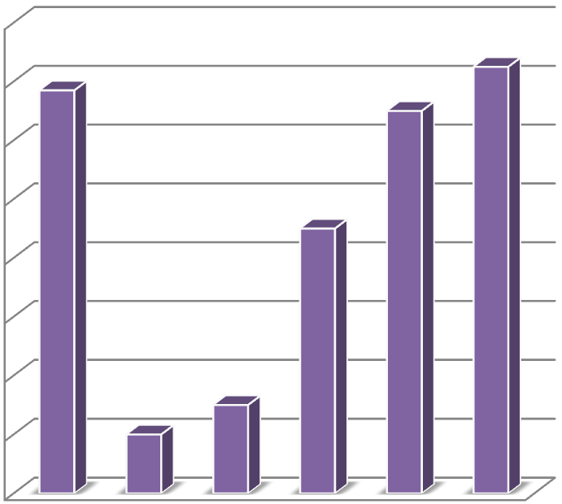

0

2,000

4,000

6,000

8,000

10,000

12,000

14,000

16,000

TOTAL AMOUNT OF RESOURCES IN THE BUSINESS

TOTAL AMOUNT OF RESOURCES IN

THE BUSINESS

The bar chart projections above indicate that, with a startup capital of GHS13,700.00, the business is anticipated to generate a gross income of about GHS14,500.00 at the end of sixth month. This means the business will virtually begin to make profit at the end of the sixth month.

*The above information can also be transferred on a graph below.*

CHART 2: Shows The Estimated Financial Projection Over Six Months Period.

0

2,000

4,000

6,000

8,000

10,000

12,000

14,000

16,000

STARTUP

MONTH

ND

2

MONTH

RD

3

MONTH

5

TH

MONTH

5

TH

MONTH

6

TH

MONTH

**TOTAL AMOUNT OF RESOURCES IN THE**

**BUSINESS**

TOTAL AMOUNT OF

RESOURCES IN THE BUSINESS

**APPENDICES**

BUSINESS PICTURES

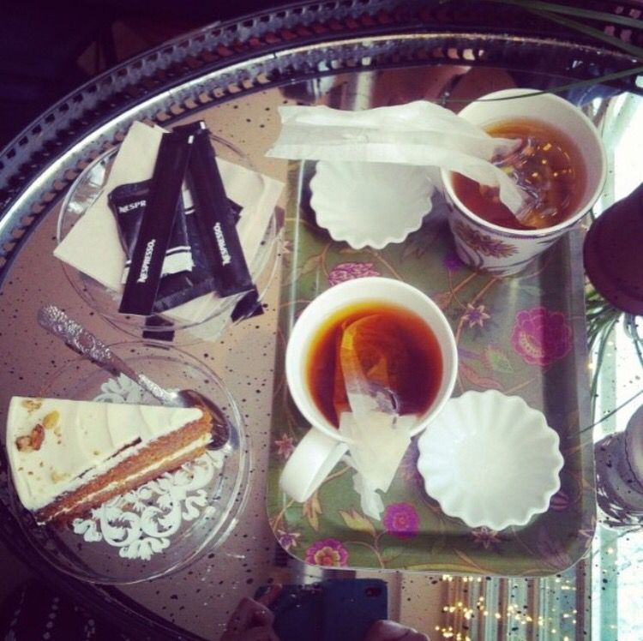

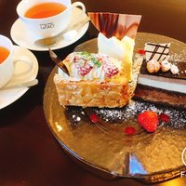

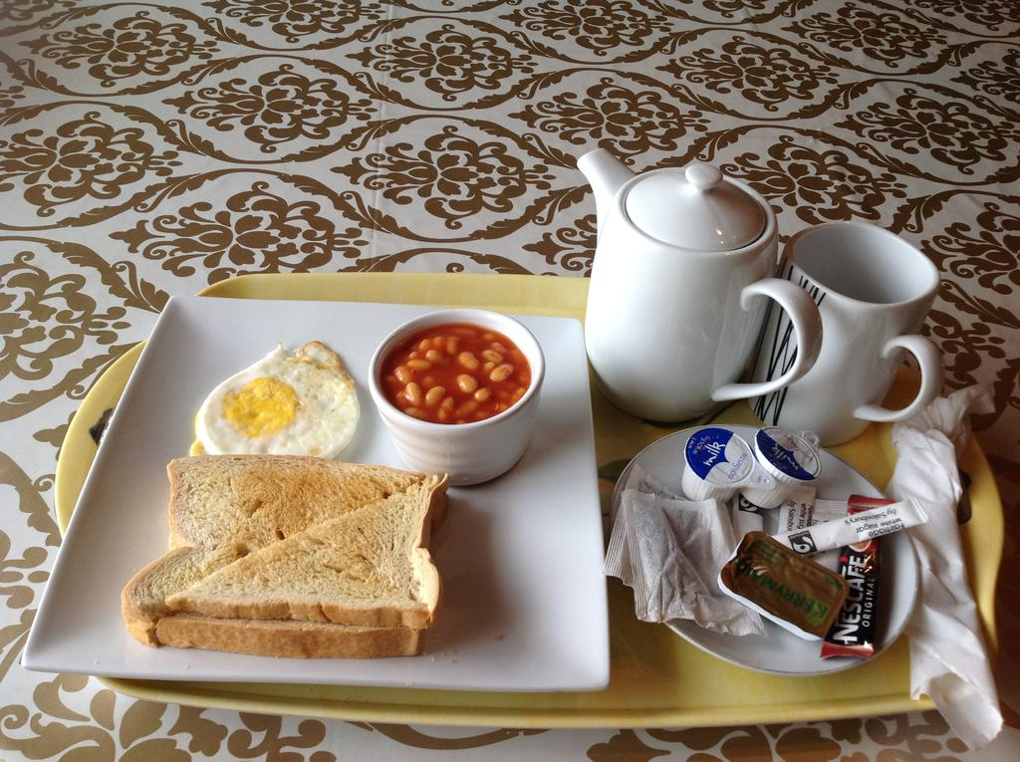

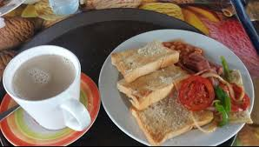

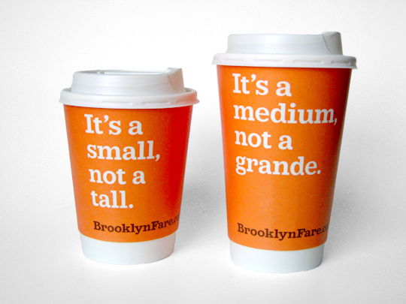

**REFERENCES**

Brunner-Sperdin, A., & Peters, M. (2005). Importance and measurement of entrepreneurial quality

and processes in tourism. *Journal of Quality Assurance in Hospitality & Tourism*, *5*(1), 73- 90.

Carroll, Z., & Ann, L. (2009). Bone Rattlers Bar & Grill business plan.

Cohn, L. (2009). Be Your Own Boss. *Kiplinger’s Personal Finance Sep2009*, 77-82.

Israeli, A. A., & Barkan, R. (2004). Developing a framework for rewards in combined

production/service businesses: The case of tipping in the restaurant industry. *International Journal of Service Industry Management*, *15*(5), 444-459.

Kim, A., Dalbor, M. C., & Feinstein, A. H. (2007). An examination of cost management behavior

in small restaurant firms. *International Journal of Hospitality Management*, *26*(2), 435-

452.

Kochkorova, F. A., Esenamanova, M. K., & Tsivinskaya, T. (2018). Diet of schoolchildren as a

risk factor of nutritional disorders. *Heart, Vessels and Transplantation*, *2*(1). No, I. (2010).

Stetsiuk, K. (2011). The Business Concept of Healthy Food Restaurant in Moscow.

Tews, M. J., & Van Hoof, H. B. (2011). In favor of hospitality-management education. *Hospitality*

*Review*, *29*(2), 8.

Wood, K. (1998). The entrepreneurial seesaw. *Restaurant Hospitality*, *82*(8), 64-64.